M

Problem Statement:
Finite element model of 2D Steady State Heat Conduction in a rectangular plate with spatially varying thermal conductivity and mixed boundary conditions.

Domain:

$T_{∞}=300K, h=\frac{25W}{m^{2} K}$
$$k=k_{0}(1+αx+βy)$$

$T_{∞}=300K$
$T=400K$ $h=25\left(\frac{W}{m^{2}K}\right)$

$$)$$

$\frac{∂T}{∂η}=0$

where $k_{0}=200\left(\frac{W}{m^{2}K}\right)$, $α=0.1$ and $β=0.05 \left(Aluminium like material\right).$

Governing Differential Equation:
$\frac{∂}{∂x}\left(k\left(x,y\right)\left(\frac{∂T}{∂x}\right)\right)+ \frac{∂}{∂y}\left(k\left(x,y\right)\left(\frac{∂T}{∂y}\right)\right)=0$

Developing Weak Form:

$$\iint{δT(}\frac{∂}{∂x}\left(k\left(\frac{∂T}{∂x}\right)\right)+ \frac{∂}{∂y}\left(k\left(\frac{∂T}{∂y}\right)\right))dxdy=0$$
Taking the first term (A1) from above equation and using integration by parts, we get
A1 = $\iint{δT\left(\frac{∂}{∂x}k\left(\frac{∂T}{∂x}\right)\right)dxdy= \int_{y_{1}}^{y_{2}}{\begin{aligned}δT\left(k{\left(\frac{∂T}{∂x}\right)}_{x_{1}}^{x_{2}}dy\right)- \int_{y_{1}}^{y_{2}}{\int_{x_{1}}^{x_{2}}{\frac{d\left(δT\right)}{dx}k(\frac{∂T}{∂x})dxdy}} \\ \end{aligned}}}$
= $\int_{y_{1}}^{y_{2}}{\int_{x_{1}}^{x_{2}}{\frac{∂}{∂x}\left(δTk\left(\frac{∂T}{∂x}\right)\right)dxdy}}- \int_{y_{1}}^{y_{2}}{\int_{x_{1}}^{x_{2}}{\frac{d\left(δT\right)}{dx}k\left(\frac{∂T}{∂x}\right)dxdy}}$

Similarly second term (A2) can be written as,
A2 = $\int_{y_{1}}^{y_{2}}{\int_{x_{1}}^{x_{2}}{\frac{∂}{∂y}(δTk\left(\frac{∂T}{∂y}\right))dxdy}}- \int_{y_{1}}^{y_{2}}{\int_{x_{1}}^{x_{2}}{\frac{d\left(δT\right)}{dy}k\left(\frac{∂T}{∂y}\right)dxdy}}$

Now combining A1 and A2 terms,
$$\left(\int_{y_{1}}^{y_{2}}{\int_{x_{1}}^{x_{2}}{\frac{∂}{∂x}\left(δTk\left(\frac{∂T}{∂x}\right)\right)+\frac{∂}{∂y}\left(δTk\left(\frac{∂T}{∂y}\right)\right)dxdy}}\right)-\left(\int_{y_{1}}^{y_{2}}{\int_{x_{1}}^{x_{2}}{(\frac{d\left(δT\right)}{dx}k\left(\frac{∂T}{∂x}\right)+\frac{d\left(δT\right)}{dy}k\left(\frac{∂T}{∂y}\right))dxdy}}\right)= 0$$

Using green’s theorem,
$$\int_{y_{1}}^{y_{2}}{\int_{x_{1}}^{x_{2}}{\frac{∂}{∂x}\left(δTk\left(\frac{∂T}{∂x}\right)\right)+\frac{∂}{∂y}\left(δTk\left(\frac{∂T}{∂y}\right)\right)dxdy}}= \oint{δT\left(k\left(\frac{∂T}{∂x}\right)η_{x}+k\left(\frac{∂T}{∂y}\right)η_{y}\right)dS}$$

Therefore, the weak form equation can be written as,
$$\int{{\left[∇\left(δT\right)\right]}^{T}\left(k∇T\right)dxdy= \oint{δT(k∇T)ηdS}}$$

LHS represents stiffness matrix due to heat conduction through area and RHS represents heat flux through boundary edges. It’s also called load vector.
To make above weak form more general, we need to include the convection boundary condition.
$$k∇Tη=-h(T-T_{∞})$$
Substituting this into the boundary integral of the above weak form(RHS), we get,
$$\oint{δT\left(k∇T\right)ηdS=\oint{-δT\left(h\left(T-T_{∞}\right)\right)dS}}$$
$$= -\oint{δThTdS+\oint{δThT_{∞}dS}}$$
Therefore the final weak form is,
$$\int{{\left[∇\left(δT\right)\right]}^{T}\left(k∇T\right)dxdy+\oint{δThTdS}= \oint{δThT_{∞}dS}}$$

Elemental Equation:
We will be using isoparametric element. Therefore, field variable can be interpolated as,
$$T=N_{1}T_{1}+N_{2}T_{2}+N_{3}T_{3}=\left[N\right][d_{e}]$$
and geometry can also be interpolated as,
$$x=N_{1}x_{1}+N_{2}x_{2}+N_{3}x_{3}=\left[N\right][x]$$
$$y=N_{1}y_{1}+N_{2}y_{2}+N_{3}y_{3}=\left[N\right][x]$$

Gradient of the T can be found as,
$$∇T=\left[\begin{matrix}\frac{∂T}{∂x} \\ \frac{∂T}{∂y}\end{matrix}\right]=\left[\begin{matrix}\frac{∂N_{1}}{∂x} & \frac{∂N_{2}}{∂x} & \frac{∂N_{3}}{∂x} \\ \frac{∂N_{1}}{∂y} & \frac{∂N_{2}}{∂y} & \frac{∂N_{3}}{∂y}\end{matrix}\right]\left[d_{e}\right]=\left[B\right][d_{e}]$$

From weak form equation,
$$∇\left(δT\right)=\left[B\right]δ\left[d_{e}\right]$$
Therefore, the LHS of weak form equation becomes,
$$\int{δ{\left[d_{e}\right]}^{T}{\left[B\right]}^{T}k\left[B\right]\left[d_{e}\right]dxdy= δ\left[d_{e}\right] (\int{{\left[B\right]}^{T}k[B]dxdy)\left[d_{e}\right] }}$$
Where,
$${[K}_{e}]= \int{{\left[B\right]}^{T}k[B]dxdy={\left[B\right]}^{T}[B]\int{k(x,y)dxdy}}$$
[B] matrix is constant since triangular element is used. $K_{e}$is not constant but depends on the surface integral of k(x,y).
Thermal conductivity for an triangular element can be given as,
$$k\left(x_{e},y_{e}\right)=k_{0}\left(1+αx+βy\right)$$
where $x=\left[N\right]\left[x\right]$ and $y=\left[N\right][y]$
Also RHS becomes,
$$\oint{δT\left(k∇T\right)ηdS={\left[d_{e}\right]}^{T}\oint{{\left[N\right]}^{T}q_{η}dS}}$$
where $\left[q_{e}\right]=\oint{{\left[N\right]}^{T}q_{η}dS}$ is the load vector for the element.
Therefore the Elemental equation becomes,
$$\left[K_{e}\right]\left[d_{e}\right]=[q_{e}]$$

Interpolation function in x-y coordinate system:
$$N_{1}=\frac{α_{1}+β_{1}x+γ_{1}y}{2A}$$
$$N_{2}=\frac{α_{2}+β_{2}x+γ_{2}y}{2A}$$
$$N_{3}=\frac{α_{3}+β_{3}x+γ_{3}y}{2A}$$
where A= area of triangular element
$$α_{1}=x_{2}y_{3}-x_{3}y_{2}$$
$$α_{2}={-x}_{1}y_{3}+x_{3}y_{1}$$
$$α_{3}=x_{1}y_{2}-x_{2}y_{1}$$

$$β_{1}=y_{2}-y_{3}$$
$$β_{2}=y_{3}-y_{1}$$
$$β_{3}=y_{1}-y_{2}$$

$$γ_{1}=x_{3}-x_{2}$$
$$γ_{2}=x_{1}-x_{3}$$
$$γ_{3}=x_{2}-x_{1}$$

Transforming the element to Natural Coordinate system:

$$ζ$$

(1,1)

$η$

(-1,-1) (1,-1)

Interpolation function in natural coordinate system can be found be assuming
$$x=a_{0}+a_{1}ζ+a_{2}η$$
$$y=b_{0}+b_{1}ζ+b_{2}η$$
Now substituting x and y values and corresponding $ζ$ and $η$ values we get interpolation function as,
$$H_{1}=\frac{1-ζ}{2}$$
$$H_{2}=\frac{ζ-η}{2}$$
$$H_{3}=\frac{1+η}{2}$$
Therefore,
$$x=H_{1}x_{1}+H_{2}x_{2}+H_{3}x_{3}$$
$$y=H_{1}y_{1}+H_{2}y_{2}+H_{3}y_{3}$$
and Jacobian matrix can be written as,
$$J=0.5\left[\begin{matrix}x_{2}-x_{1} & x_{3}-x_{2} \\ y_{2}-y_{1} & y_{3}-y_{2}\end{matrix}\right]$$
Therefore the elemental stiffness matrix can be found as,
$$K_{e}=k_{0}{\left[B\right]}^{T}\left(\int{\left(1+α\left[H\right]\left[x\right]+β\left[H\right]\left[y\right]\right)|J|dζdη}\right)[B]$$
Where $-1≤ζ≤1$ and $-1≤η≤1$
The order of polynomial inside the surface integral will be 1, so only 1 gauss point is required which is going to be ($\frac{1}{3},-\frac{1}{3}$) and weight= 2.
For every element, $K_{e}$ will change depending upon the coordinates of the vertices. The integral
$$\int_{-1}^{1}{\int_{-1}^{1}{\left[H\right]\left|J\right|dζdη=\left[\frac{2}{3}\frac{2}{3}\frac{2}{3}\right]|J|}}$$

Applying convection boundary condition:
Note that convection boundary condition is applied to only the top and right boundary edges, as convection stiffness becomes zero for the all other edges. Insulated boundary condition does not contribute to the stiffness and load vector.
The boundary edges can be treated as linear element, the shape functions will be
$$N_{1}=\frac{1-ζ}{2}$$
$$N_{1}=\frac{1+ζ}{2}$$
Using the final weak form equation,
$$\int{{\left[∇\left(δT\right)\right]}^{T}\left(k∇T\right)dxdy+\oint{δThTdS}= \oint{δThT_{∞}dS}}$$
2nd term on the LHS acts as convection stiffness. This can be converted into matrix form as
$$K_{h}=\oint{h{\left[N\right]}^{T}\left[N\right]dS}$$
After converting into natural coordinate system, we get
$$K_{h}=\oint{h[\begin{matrix}N_{1}^{2} & N_{1}N_{2} \\ N_{1}N_{2} & N_{2}^{2}\end{matrix}}]\frac{L_{e}}{2}dζ$$
After integration we get,
$$K_{h}=\frac{hL_{e}}{6}\left[\begin{matrix}2 & 1 \\ 1 & 2\end{matrix}\right]$$
This the convection stiffness matrix for the top and right boundary edge.
The RHS of the above weak form can be written as,
$$F_{h}=\oint{h{\left[N\right]}^{T}T_{∞}dS}$$
$$F_{h}=\frac{\left(hT_{∞}L_{e}\right)}{2}\left[\begin{matrix}1 \\ 1\end{matrix}\right]$$
This the load vector due to convection at the top and right edges.

MATLAB code results:
Dividing the entire domain in 20X10 rectangular sections and dividing each section in 2 triangles through diagonal. Therefore total no. of triangular elements obtained will be 400.
Triangular mesh obtained will as shown below,
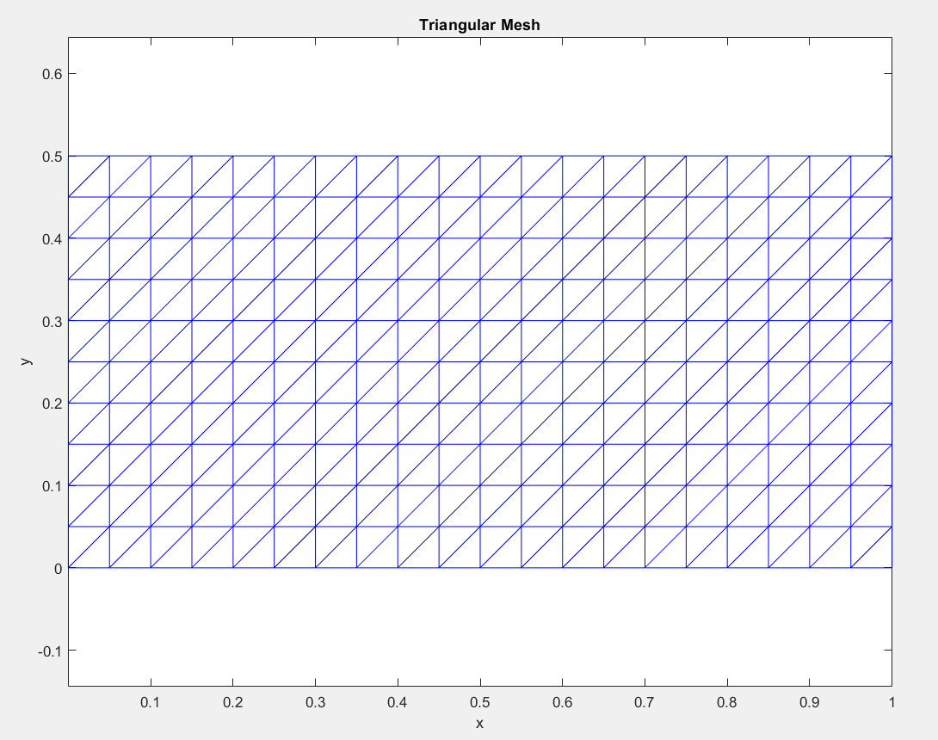
Global stiffness matrix obtained will be,
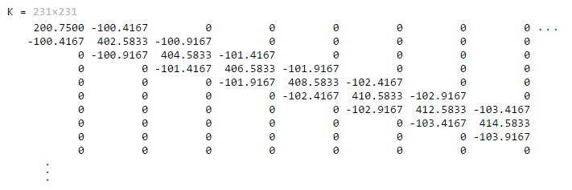

And globel load vector obtained will be,
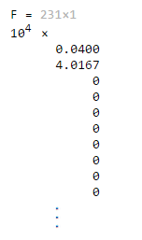
Temperature vector obtained will be,
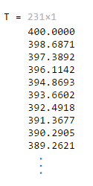
Temperature distribution:
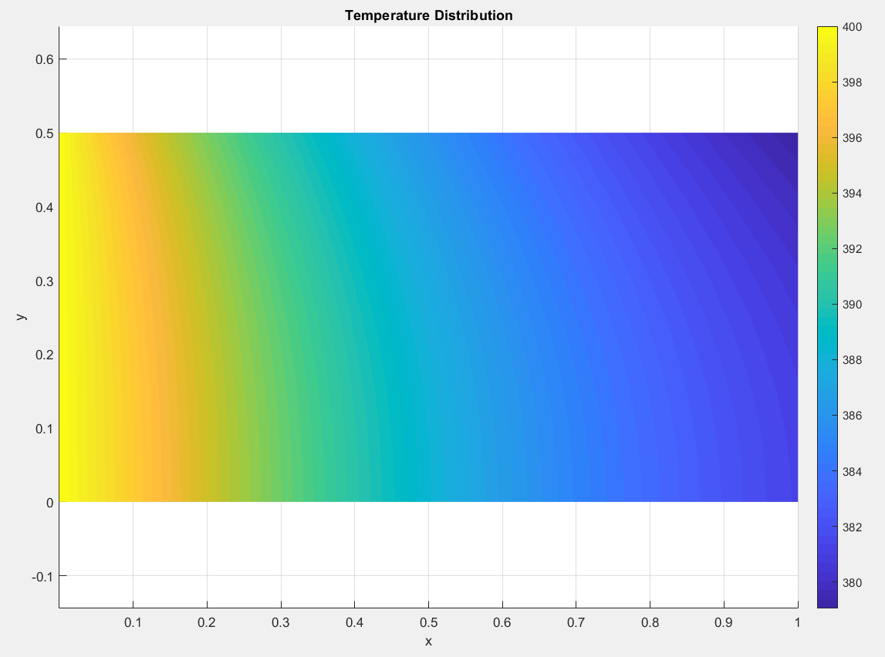
Total heat transfer from the top + right boundary edge is obtained as: 3180.5 W
Maximum Temperature: 400K
Minimum Temperature: 379

MATLAB code:
clc;
clear;
close all;

% 1. Parameters

L = 1.0; % Plate length (m)
H = 0.5; % Plate height (m)

nx = 20; % Number of divisions in x
ny = 10; % Number of divisions in y

k0 = 200; % Base thermal conductivity
alpha = 0.1; % Conductivity variation in x
beta = 0.05; % Conductivity variation in y

h = 25; % Convection coefficient
T_inf = 300; % Ambient temperature
T_left = 400; % Left edge temperature

tol = 1e-12;

% 2. Generating Nodes

dx = L/nx;
dy = H/ny;

nodes = [];

for j = 0:ny

for i = 0:nx

x = i*dx;
y = j*dy;

nodes = [nodes; x y];

end

end

nodes
num_nodes = size(nodes,1)

% 3. Generating triangular elements

elements = [];

for j = 1:ny

for i = 1:nx

n1 = (j-1)*(nx+1) + i;
n2 = n1 + 1;

n4 = j*(nx+1) + i;
n3 = n4 + 1;

% Triangle 1
elements = [elements; n1 n2 n3];

% Triangle 2
elements = [elements; n1 n3 n4];

end

end

elements
num_elements = size(elements,1)

% 4. Plotting triangular mesh

figure

triplot(elements, nodes(:,1), nodes(:,2),'b')

axis equal

xlabel('x')
ylabel('y')

title('Triangular Mesh')

% 5. Initialize the global matrices

K = zeros(num_nodes,num_nodes);

F = zeros(num_nodes,1);

% 6. Element loops

for e = 1:num_elements

element_nodes = elements(e,:); % element nodes

% Coordinates of nodes
x1 = nodes(element_nodes(1),1);
y1 = nodes(element_nodes(1),2);

x2 = nodes(element_nodes(2),1);
y2 = nodes(element_nodes(2),2);

x3 = nodes(element_nodes(3),1);
y3 = nodes(element_nodes(3),2);

% Jacobian Matrix

dx_dxi = (-0.5*x1) + (0.5*x2);
dy_dxi = (-0.5*y1) + (0.5*y2);

dx_deta = (-0.5*x2) + (0.5*x3);
dy_deta = (-0.5*y2) + (0.5*y3);

J = [dx_dxi dy_dxi;
dx_deta dy_deta];

detJ = det(J);

invJ = inv(J);

% Shape function derivatives wrt xi and eta

dN_dxi = [-0.5; 0.5; 0.0];

dN_deta = [0.0; -0.5; 0.5];

% Derivatives wrt x and y [B]

gradN = invJ * [dN_dxi'; dN_deta'];

dN_dx = gradN(1,:);
dN_dy = gradN(2,:);

% B matrix

B = [dN_dx; dN_dy];

% Gauss Point

xi = 1/3;
eta = -1/3;

weight = 2;

% Shape functions at Gauss point

N1 = 0.5*(1 - xi);

N2 = 0.5*(xi - eta);

N3 = 0.5*(1 + eta);

N = [N1 N2 N3];

% Coordinates at Gauss point

x_gp = N*[x1; x2; x3];

y_gp = N*[y1; y2; y3];

% Spatially variable thermal conductivity

k = k0*(1 + alpha*x_gp + beta*y_gp);

% Element stiffness matrix

Ke = (B'*k*B)*detJ*weight;

% Assembly

for i = 1:3

for j = 1:3

K(element_nodes(i), element_nodes(j)) = K(element_nodes(i), element_nodes(j)) + Ke(i,j);

end

end

end

% 7. Apply convection boundary condition

for e = 1:num_elements

element_nodes = elements(e,:);

edge_list = [1 2; 2 3; 3 1];

for edge = 1:3

local_nodes = edge_list(edge,:);

n1 = element_nodes(local_nodes(1));
n2 = element_nodes(local_nodes(2));

p1 = nodes(n1,:);
p2 = nodes(n2,:);

% TOP EDGE

if abs(p1(2)-H)<tol && abs(p2(2)-H)<tol

Le = norm(p2-p1);

Kh = h*Le/6 * [2 1; 1 2];

Fh = h*T_inf*Le/2 * [1; 1];

edge_nodes = [n1 n2];

K(edge_nodes,edge_nodes) = K(edge_nodes,edge_nodes) + Kh;

F(edge_nodes) = F(edge_nodes) + Fh;

end

% RIGHT EDGE

if abs(p1(1)-L)<tol && abs(p2(1)-L)<tol

Le = norm(p2-p1);

Kh = h*Le/6 * [2 1; 1 2];

Fh = h*T_inf*Le/2 * [1; 1];

edge_nodes = [n1 n2];

K(edge_nodes,edge_nodes) = K(edge_nodes,edge_nodes) + Kh;

F(edge_nodes) = F(edge_nodes) + Fh;

end

end

end
K
F

% 8. Apply dirichlet boundary condition

left_nodes = [];

for i = 1:num_nodes

if abs(nodes(i,1)) < tol

left_nodes = [left_nodes; i];

end

end

for i = 1:length(left_nodes)

node = left_nodes(i);

F = F - K(:,node)*T_left;

K(node,:) = 0;
K(:,node) = 0;

K(node,node) = 1;

F(node) = T_left;

end
F

% 9. Solving system of equations

T = K\F;
T

% 10. Temperature contour plot

figure

trisurf(elements, nodes(:,1), nodes(:,2), T, 'EdgeColor','none')

view(2)

axis equal

xlabel('x')
ylabel('y')

title('Temperature Distribution')

colorbar

shading interp

% 11. Post Processing and results

fprintf('Maximum Temperature = %.2f K\n',max(T));

fprintf('Minimum Temperature = %.2f K\n',min(T));

% 12. Boundary Heat Flux Calculation

Q_total = 0;

fprintf('\nBoundary Heat Flux Results:\n');

for e = 1:num_elements

element_nodes = elements(e,:);

edge_list = [1 2;
2 3;
3 1];

for edge = 1:3

local_nodes = edge_list(edge,:);

n1 = element_nodes(local_nodes(1));
n2 = element_nodes(local_nodes(2));

p1 = nodes(n1,:);
p2 = nodes(n2,:);

% Top edge convection

if abs(p1(2)-H)<tol && abs(p2(2)-H)<tol

Le = norm(p2-p1); % edge length

% 1-point Gauss quadrature
xi = 0;
weight = 2;

% Shape functions at Gauss point
N1 = 0.5*(1-xi);
N2 = 0.5*(1+xi);

Nedge = [N1 N2];

Te = [T(n1); T(n2)]; % Edge nodal temperatures

T_gp = Nedge*Te; % Temperature at Gauss point

q = h*(T_gp - T_inf); % Boundary heat flux

J_edge = Le/2; % Jacobian for line element

Qe = q*J_edge*weight; % Heat transfer through edge

Q_total = Q_total + Qe; % Total heat transfer

fprintf('Top Edge (%d-%d): q = %.4f W/m^2\n', n1,n2,q);

end

% Right convection edge

if abs(p1(1)-L)<tol && abs(p2(1)-L)<tol

Le = norm(p2-p1);

xi = 0;
weight = 2;

N1 = 0.5*(1-xi);
N2 = 0.5*(1+xi);

Nedge = [N1 N2];

Te = [T(n1); T(n2)];

T_gp = Nedge*Te;

q = h*(T_gp - T_inf);

J_edge = Le/2;

Qe = q*J_edge*weight;

Q_total = Q_total + Qe;

fprintf('Right Edge (%d-%d): q = %.4f W/m^2\n', n1,n2,q);

end

end

end

fprintf('\nTotal Convective Heat Transfer = %.4f W\n',Q_total);

